AI-powered Nutrition Analyzer for Fitness Enthusiasts

**Team ID:PNT2022TMID02994**

**Project Report Format**

# INTRODUCTION

* 1. **Project Overview**

Food is essential for human life and has been the concern of many healthcare conventions. Nowadays new dietary assessment and nutrition analysis tools enable more opportunities to help people understand their daily eating habits, exploring nutrition patterns and maintain a healthy diet.Nutritional analysis is the process of determining the nutritional content of food. It is a vital part of analytical chemistry that provides information about the chemical composition, processing, quality control and contamination of food.

# Purpose

The main aim of the project is to building a model which is used for classifying the fruit depends onthe different characteristics like colour, shape, texture etc. Here the user can capture the images ofdifferent fruits and then the image will be sent the trained model. The model analyses the image and detect the nutrition based on the fruits like (Sugar, Fibre, Protein, Calories, etc.).

# LITERATURE SURVEY

* 1. **Existing problem**

Neutrino delivers nutrition-based data services and analytics to its users and wants to turn into aleading source of the nutrition-related platform. The platform employs NLP and mathematical models from the optimization theory as well as predictive analysis to enable individualized data compilation.

The application relies on Artificial Intelligence to produce custom data related to smart calorie counter powered by AI. Their artificial intelligence learns an individual’s tastes, preferences, andbody type. All of this is packaged in a comprehensive nutrition and activity tracker.

# 2.3 Problem Statement Definition

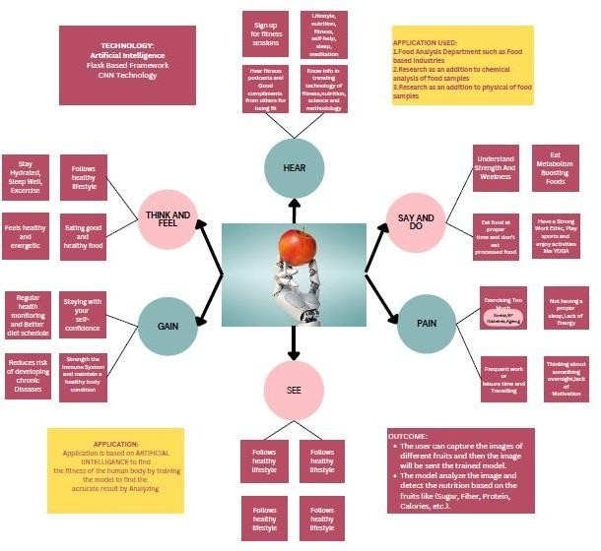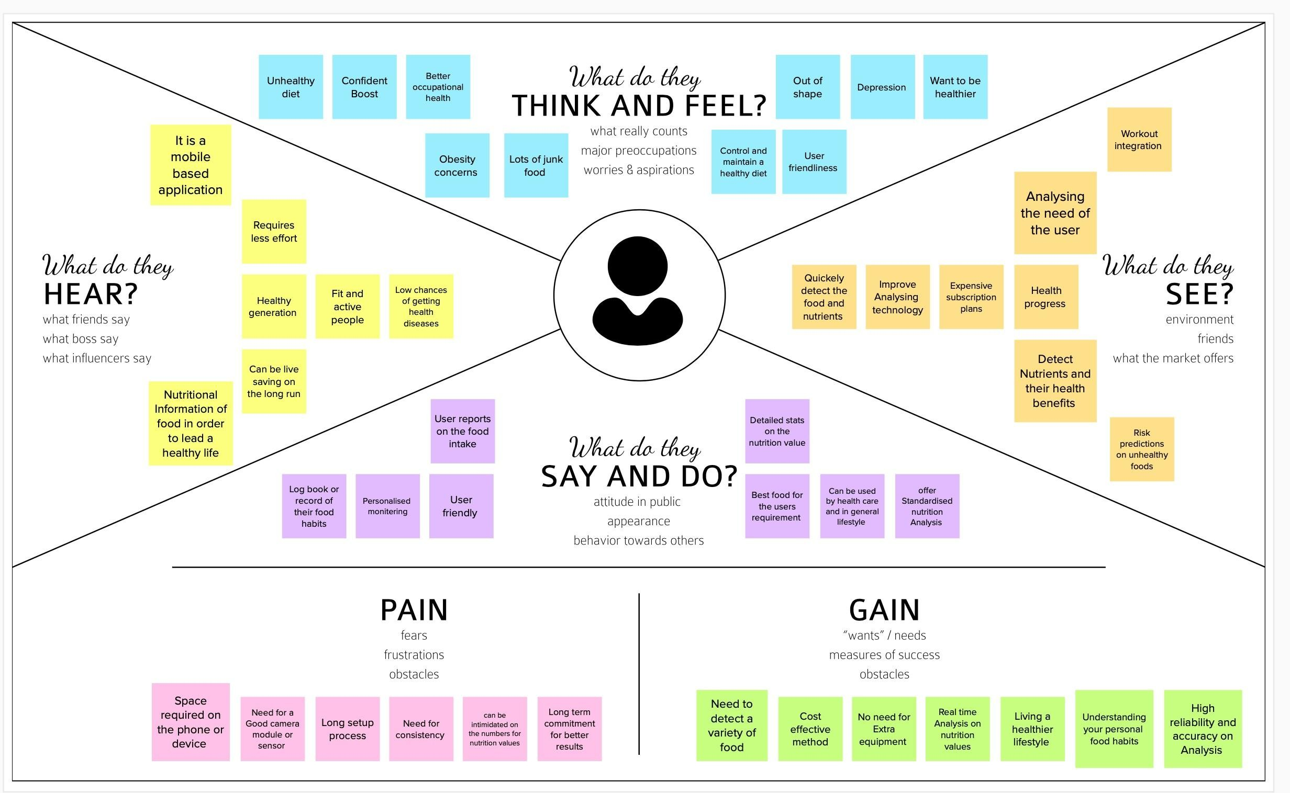

The main aim of the project is to building a model which is used for classifying the fruit depends onthe different characteristics like colour, shape, texture etc. Here the user can capture the images ofdifferent fruits and then the image will be sent the trained model. The model analyses the image and detect the nutrition based on the fruits like (Sugar, Fibre, Protein, Calories, etc.).

# IDEATION & PROPOSED SOLUTION

**3.1Empathy Map Canvas**

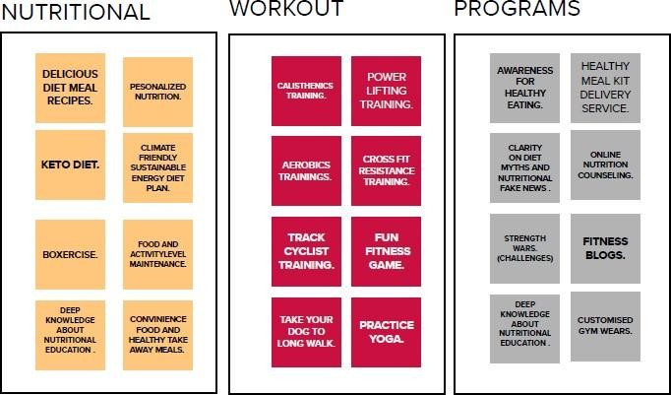

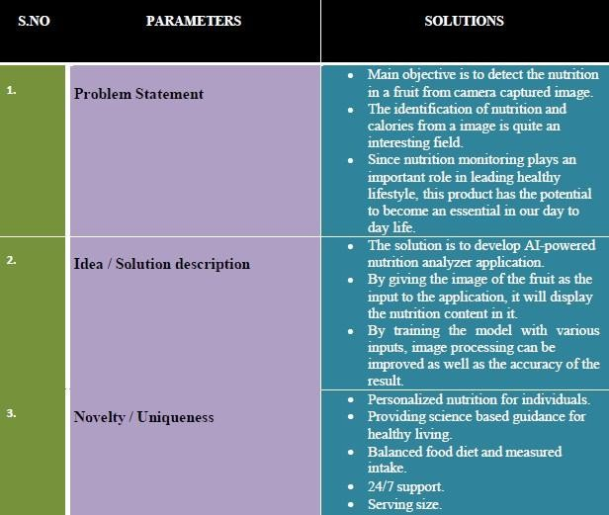**3.2** Proposed Solution

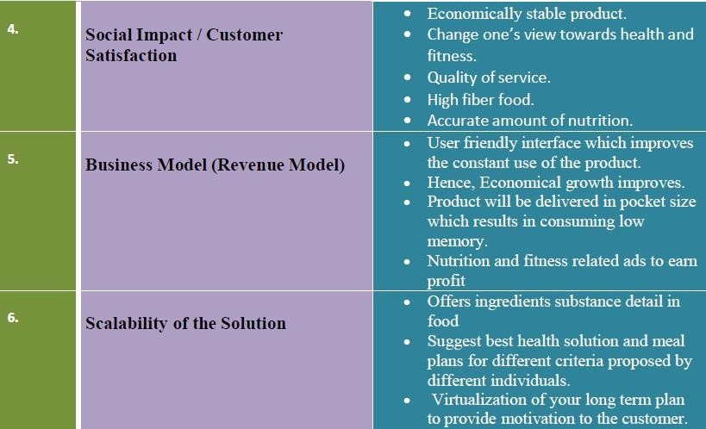

# Problem Solutionfit

The Problem-Solution Fit simply means that you have found a problem with your customer andthat the solution you have realized for it actually solves the customer’s problem. It helps entrepreneurs, marketers and corporate innovators identify behavioral patterns

# Purpose:

* + - Solve complex problems in a way that fits the state of your customers.
    - Succeed faster and increase your solution adoption by tapping into existing mediumsand channels of behavior.
    - Sharpen your communication and marketing strategy with the right triggers andmessaging.
    - Increase touch-points with your company by finding the right problem- behavior fit andbuilding trust by solving frequent annoyances, or urgent or costly problems.

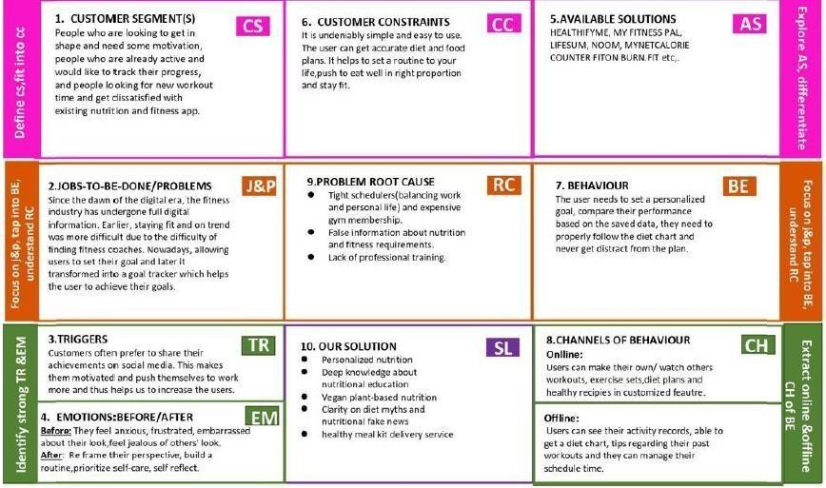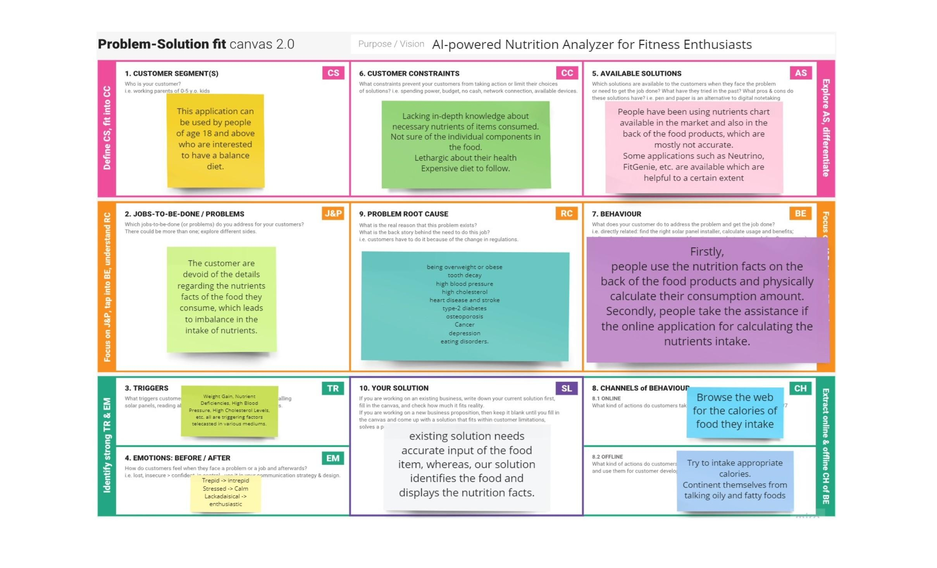

# REQUIREMENT ANALYSIS

* 1. **Functional requirement**
     + It will generate the diet plan as well as monitor the user’s health to classify the category of the disease and to create the diet plan. It will also reduce the cost of consulting the personnutritionist.
     + The task of food detection/classification is not easy as it seems. All possible options relatedto the given Image.
     + Image classification, object detection, segmentation, face recognition.
     + Classification of crystal structure using a convolutional neural network
     + Nutrition is vital to the growth of the human body. Nutritional analysis guarantees that themeal meets the appropriate vitamin and mineral requirements, and the examination of nutrition in food aids in understanding the fat proportion, carbohydrate dilution, proteins,fiber, sugar, and so on. Another thing to keep in mind is not to exceed our daily calorie requirements
     + Computer-Assisted Nutritional Recognize Food Images – In order to solve this issue, a brand-new Convolutional Neural Network (CNN)- based food picture identification system was

created, as described in this study. We utilized our suggested strategy on two sets of actualfood picture data.

* + - Here the user can capture the images of different fruits and then the image will be sent tothe trained model. The model analyzes the image and detects the nutrition based on the fruits like (Sugar, Fiber, Protein, Calories, etc.)
    - The Ultimate Workout at Home Solution This fitness AI software is designed with personalized training regimens for each individual. It began as “gym only software,” but hasnow improved its system to satisfy “at home fitness” expectations.
    - You take a picture, dial in data such as whether you are eating breakfast or lunch and add aquick text label, and the app estimates the calorie content.
    - This software collaborated with IBM’s natural language capability to provide 24-hourassistance and dietary recommendations.

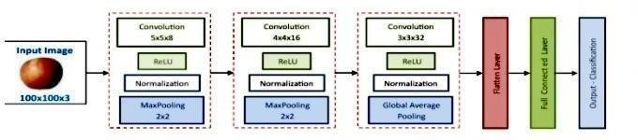For Example:

* + - The comparison of the proposed model with the conventional models shows that the resultsof this model are exceptionally good and promising to use in real-world applications.
    - This sort of higher accuracy and precision will work to boost the machine’s generalefficiency in fruit recognition more appropriately.
    - A generic model for the dietary protein requirement (as with any nutrient) defines therequirement in terms of the needs of the organism,
    - i.e. metabolic demands, and the dietary amount which will satisfy those needs, i.e. efficiency of utilization, thus: dietary requirement = metabolic demand/efficiency of utilization.

# PROJECT DESIGN

* 1. **Data Flow Diagrams**

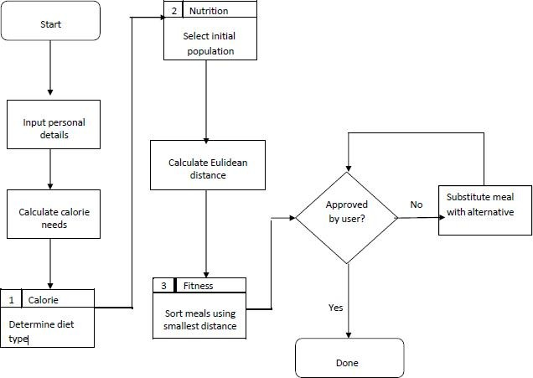

# Solution & Technical Architecture

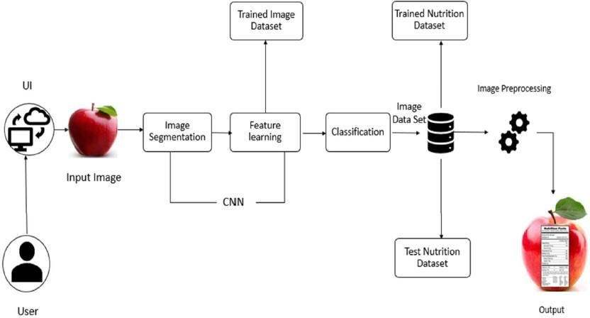

**S.No Component Description Technology**

1. App User interacts with application

for the prediction of Nutrition

1. Database Data Type, Configurations and

data will be stored

Python, Java, HTML,

SQLite, Android studio

MySQL, JS

1. Cloud Database Database Service on Cloud IBM DB2, IBM

Cloudant etc.

1. File Storage File storage requirements Cloud -- > drive
2. Machine Learning Model

Purpose of Machine Learning Model

ANN, CNN, RNN

1. Notification Notification will be sent from the server

SendGrid

# Application Characteristics:

**S.No Characteristics Description Technology**

1. Open-Source

Frameworks

1. Security

Implementations

1. Scalable

Architectur e

Open-source frameworks used

Request authentication using encryption

The scalability of architectureconsists of 3 tiers

SendGrid, Python, JQuery

Encryptions, SSL certs

Web Server – HTML,

CSS ,Javascript Application Server

–Python Flask

Database Server – IBM

Cloud

1. Availability Availability is increased by loads

balancers in cloud VPS

1. Performance The application is expected to handle up to 4000 predications

per second

IBM Cloud hosting

IBM Load Balance

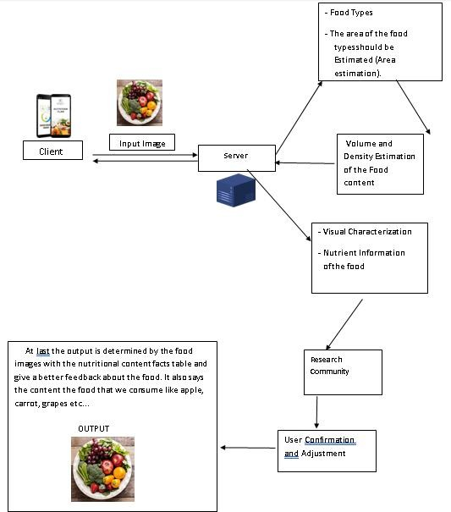

# CODING & SOLUTIONING (Explain the features added in the project along with code)

* 1. 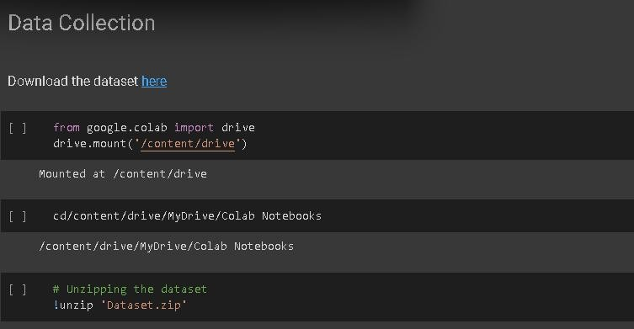Feature 1

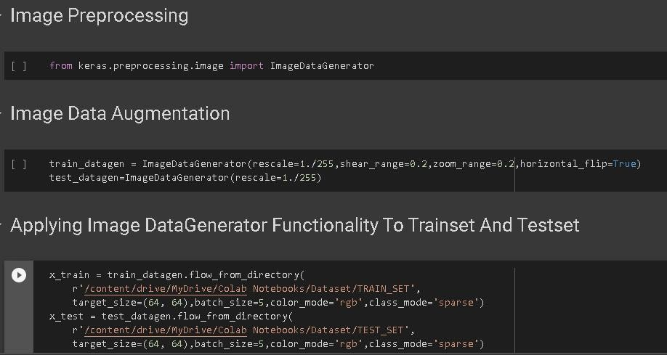

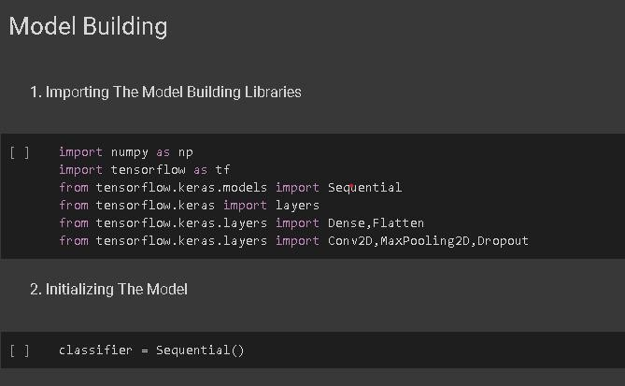

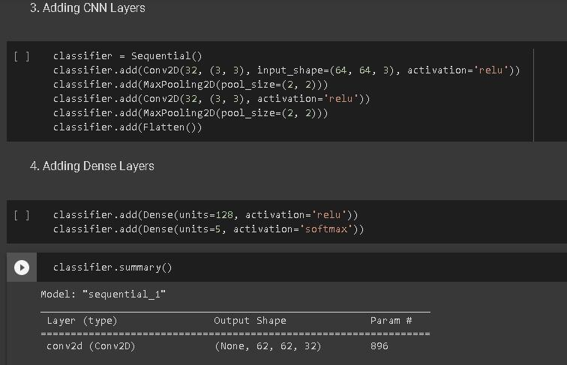

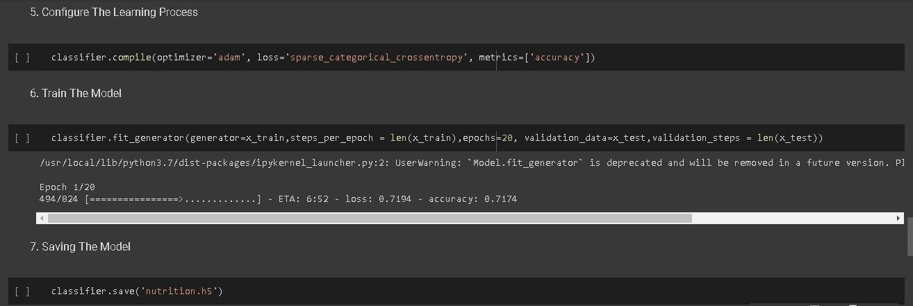

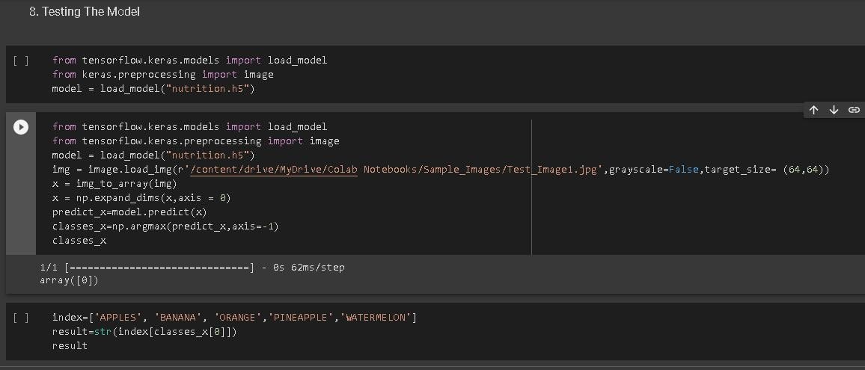

* 1. Feature 2

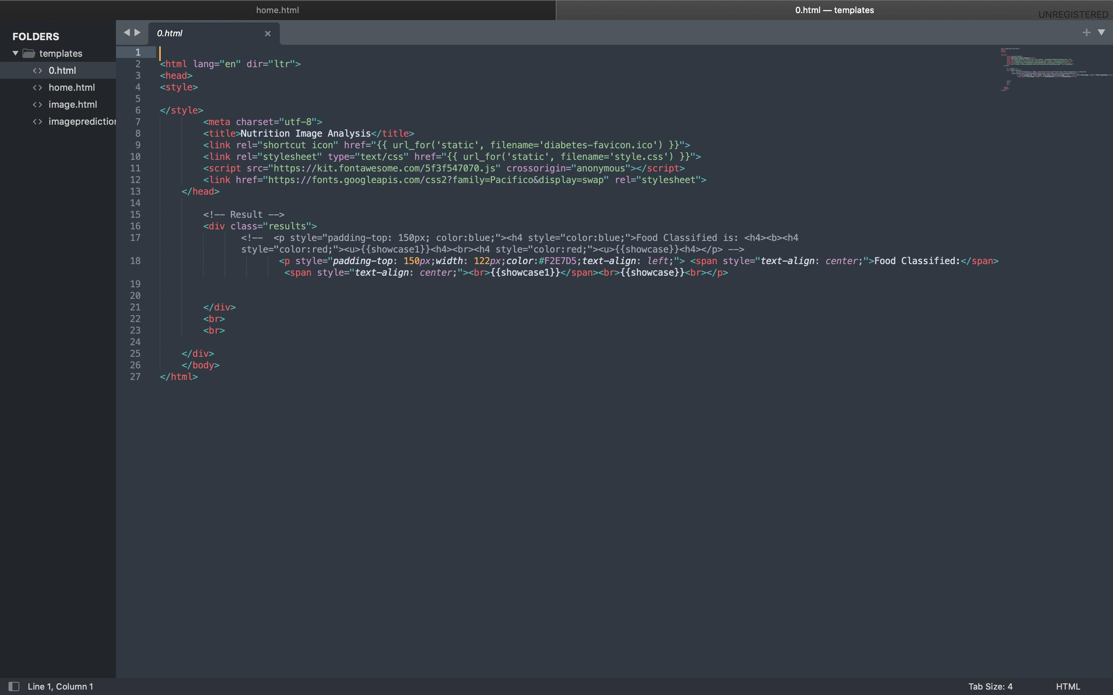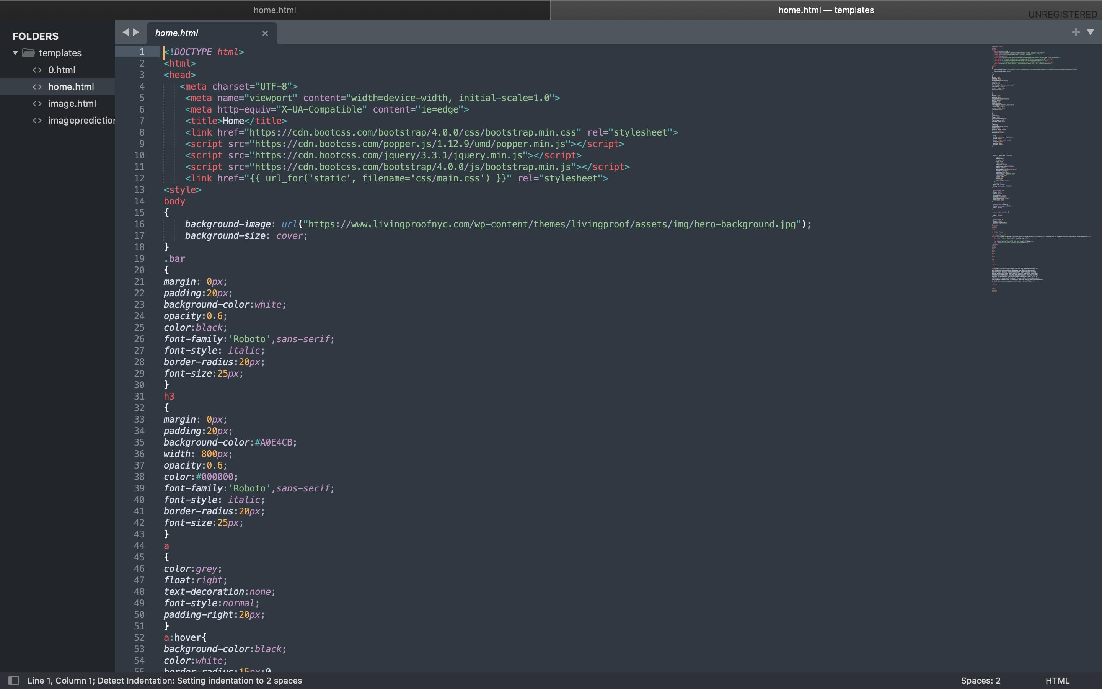

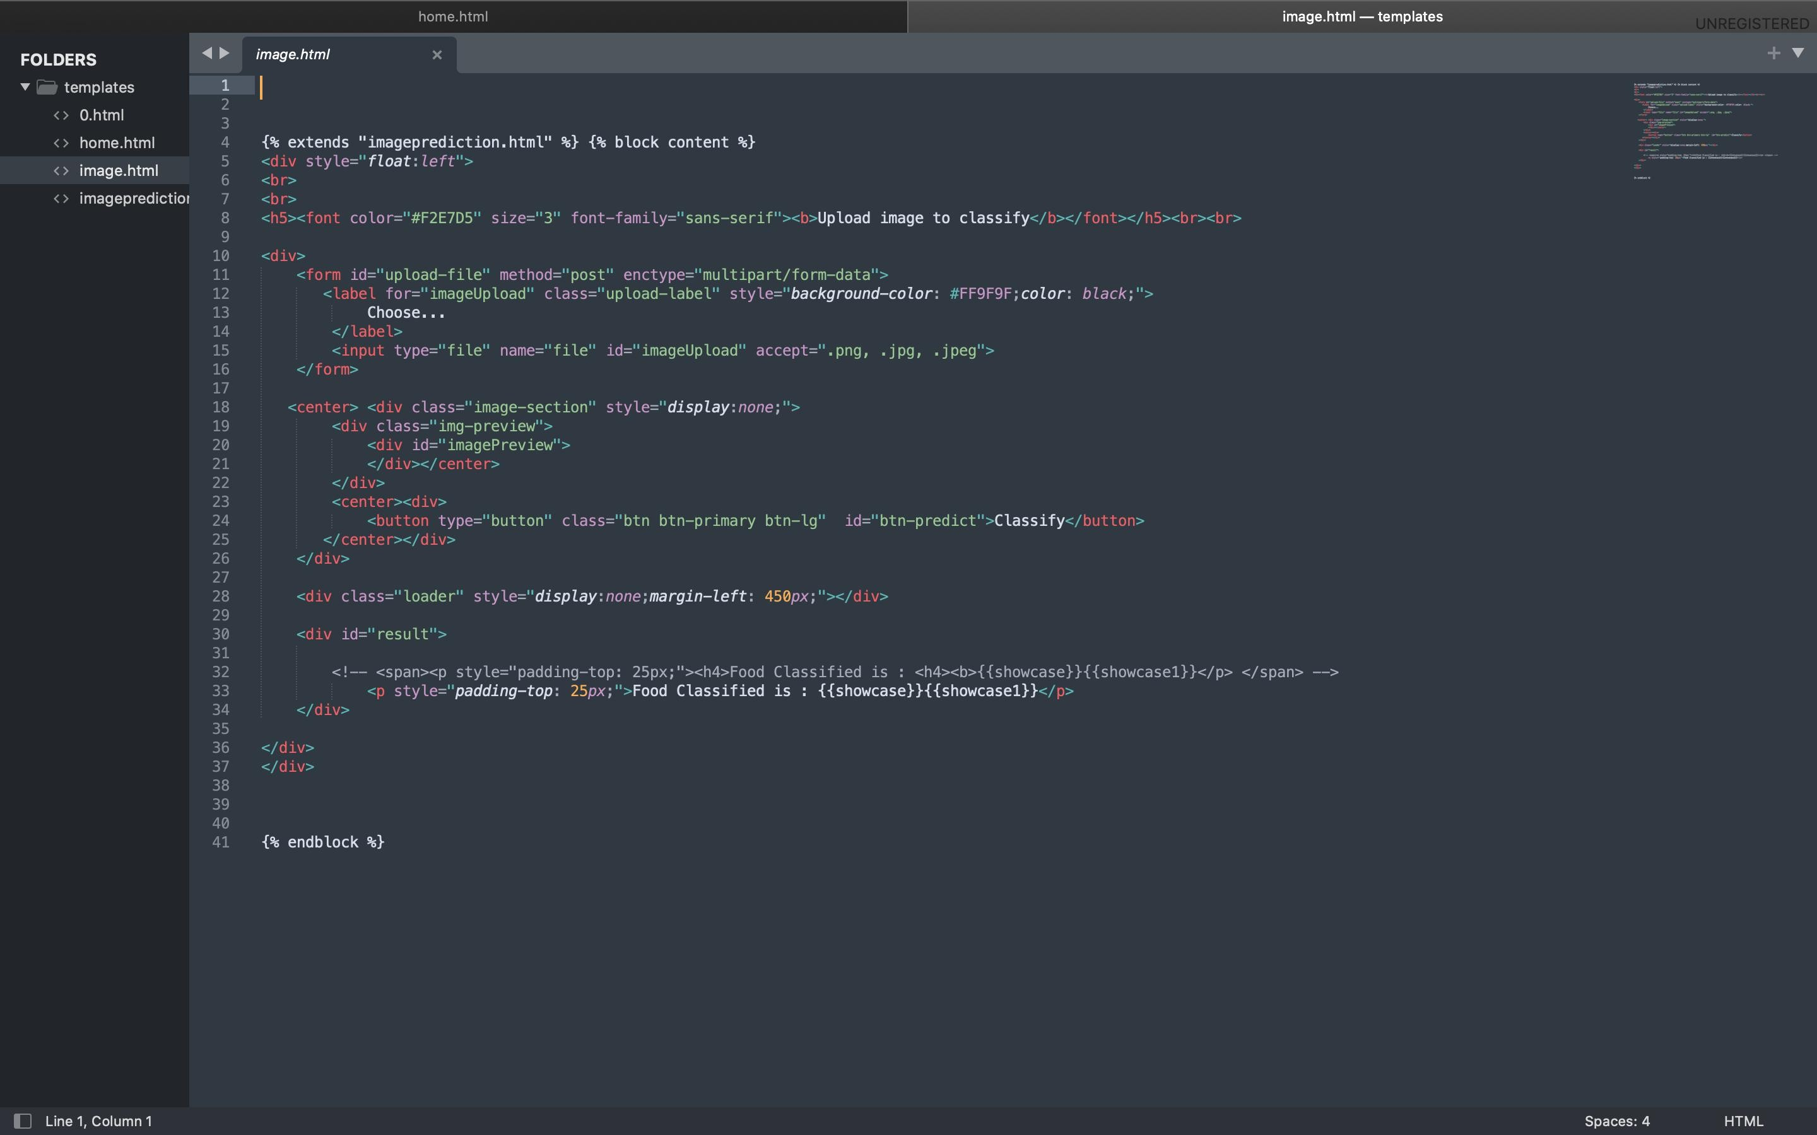

# TESTING

* 1. 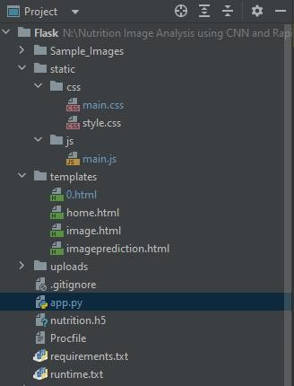**Test Cases**

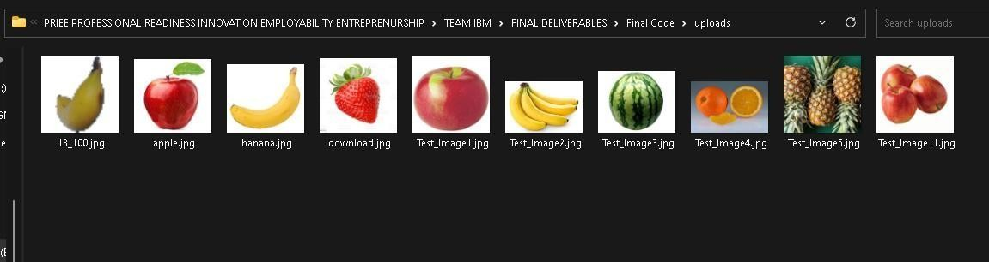

# User Acceptance Testing

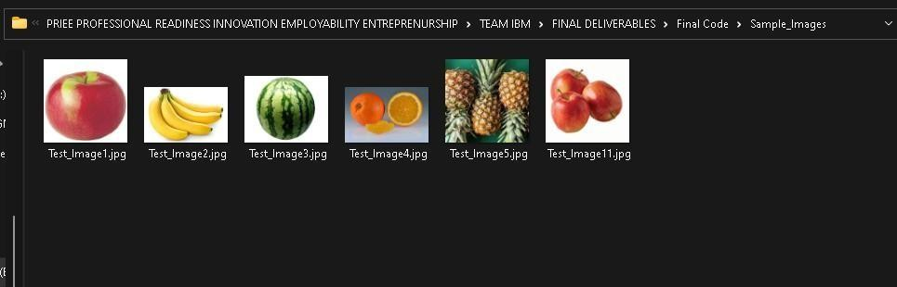

1. **RESULTS**

# Performance Metrics

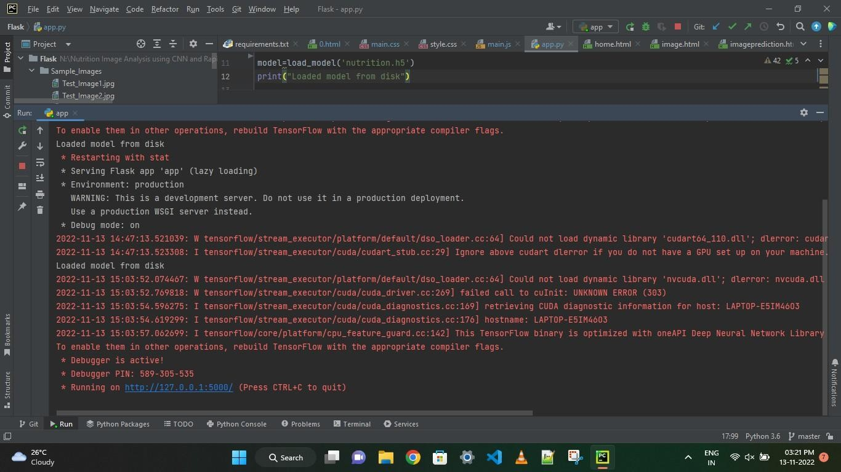

* 1. 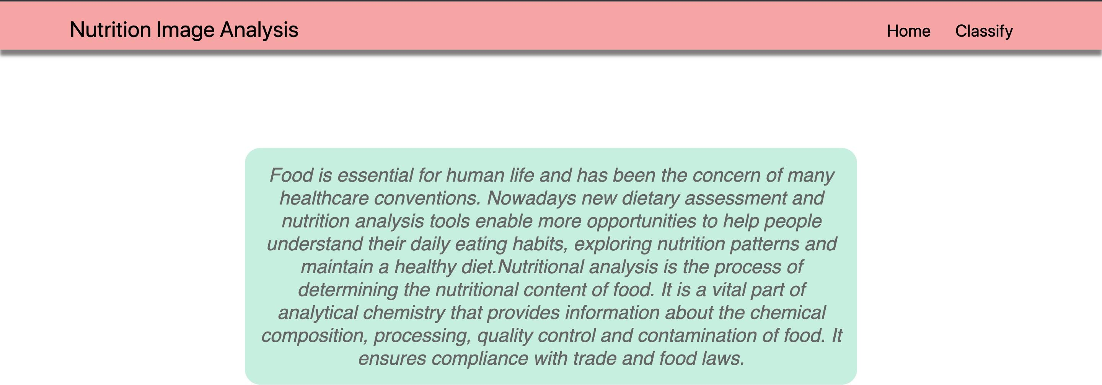Output

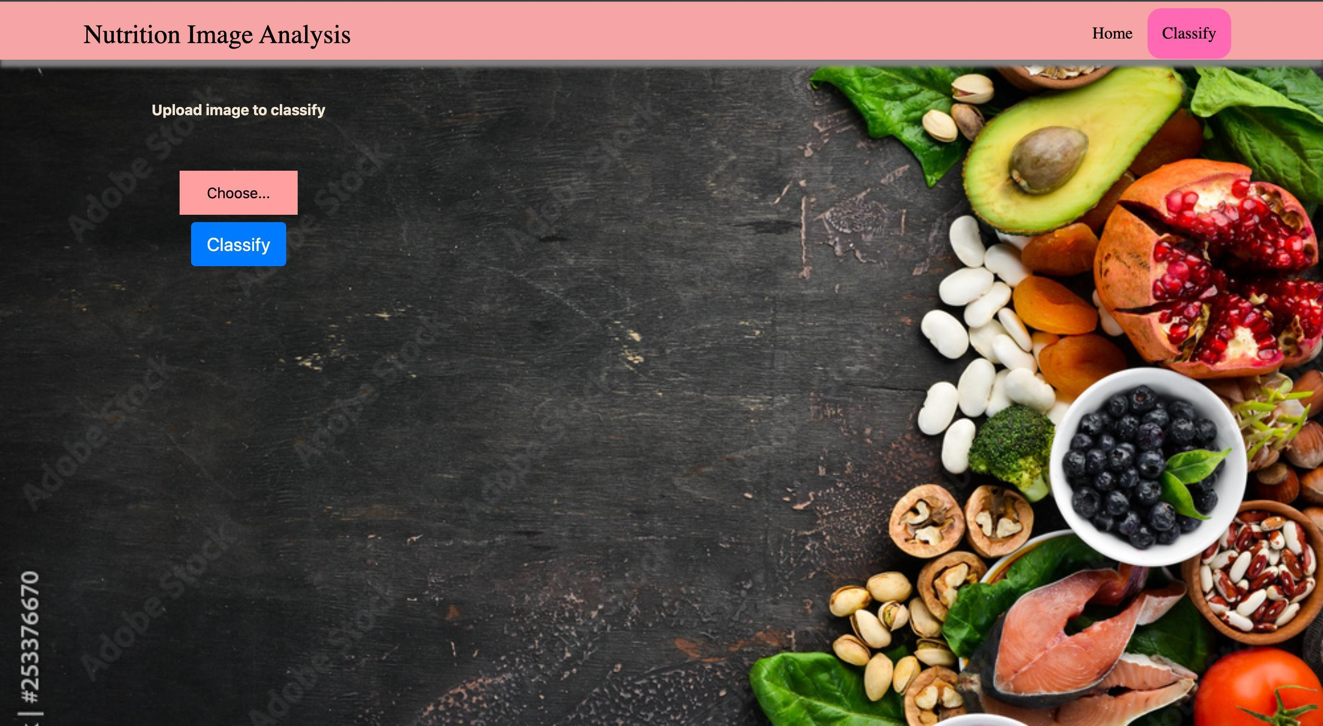

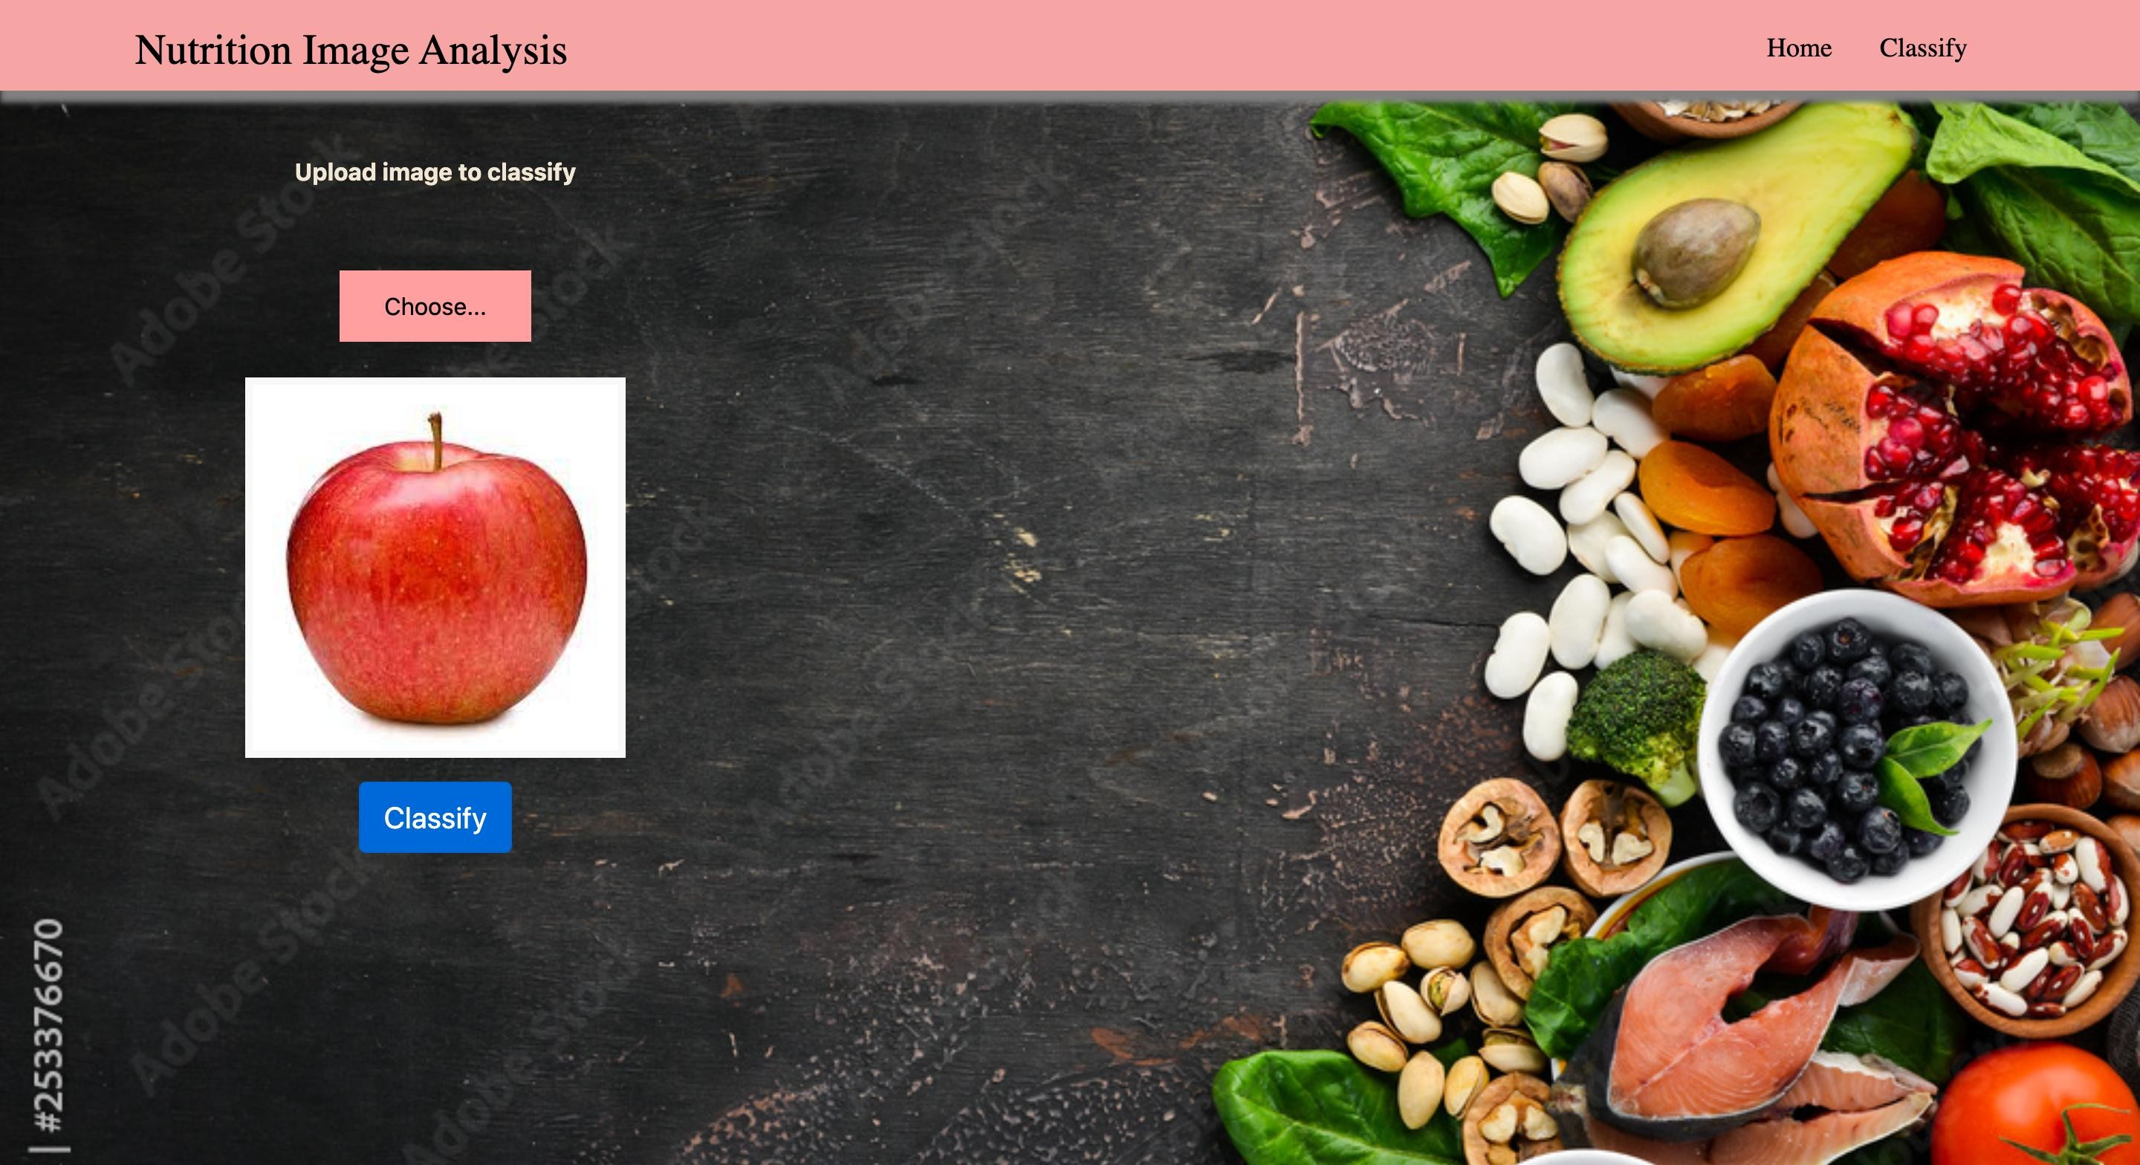

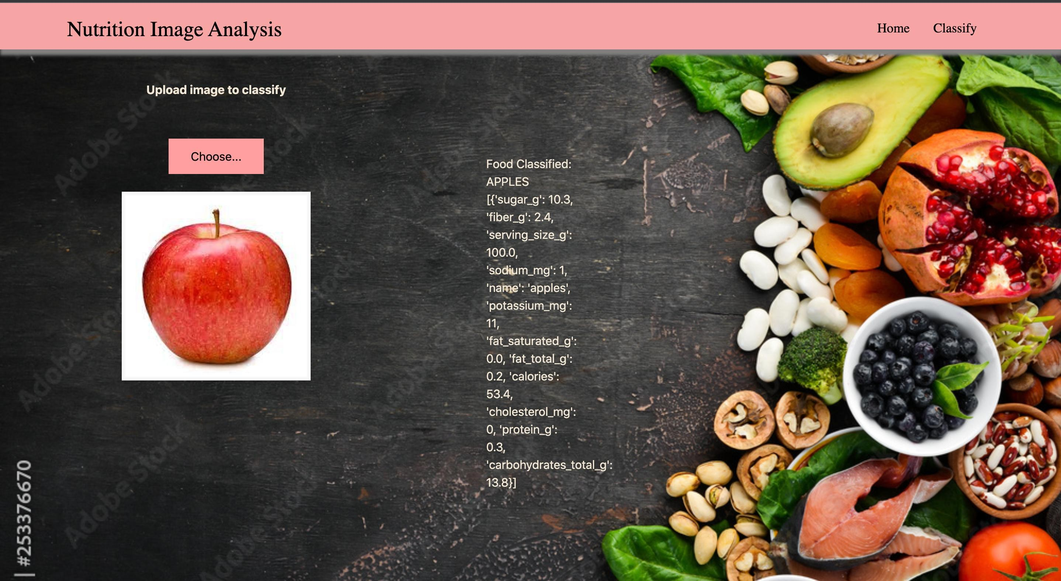

# CONCLUSION

By the end of this project we will

* know fundamental concepts and techniques of Convolutional Neural Network.
* gain a broad understanding of image data
* know how to build a web application using the Flask framework.
* know how to pre-process data and
* know how to clean the data using different data preprocessing techniques.

# FUTURE SCOPE

* AI is revolutionizing the health industry.
* It is majorly used in improving marketing and sales decisions, AI is now also being used to reshape individual habits.
* In future we don’t want to go to gym and do any diets. By using this nutrition fitness analyzer we can maintain our diet plans without any help from others and we can lead a happy and healthy life with good wealth.
* AI can easily track health behaviors and repetitive exercise patterns and use the data to guide you towards your fitness journey and diet plans .